Computer Vision Homework 10

Name: 黃新予

Student ID: f08922136

Three functions are implemented.

1. def paddingArray(array): padding array for filtering. if kernel is 3x3, padding one time if 11x11, padding 5 times.  
   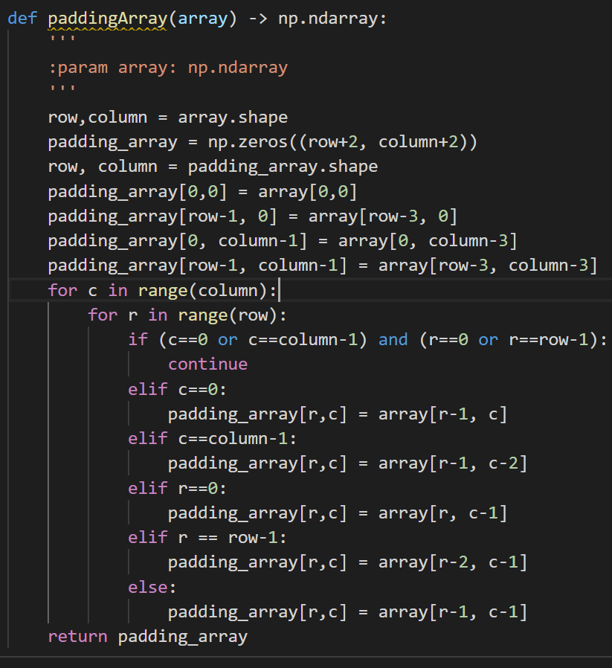
2. def Laplacian(image, kernel, threshold): create {1,0,-1} array  
   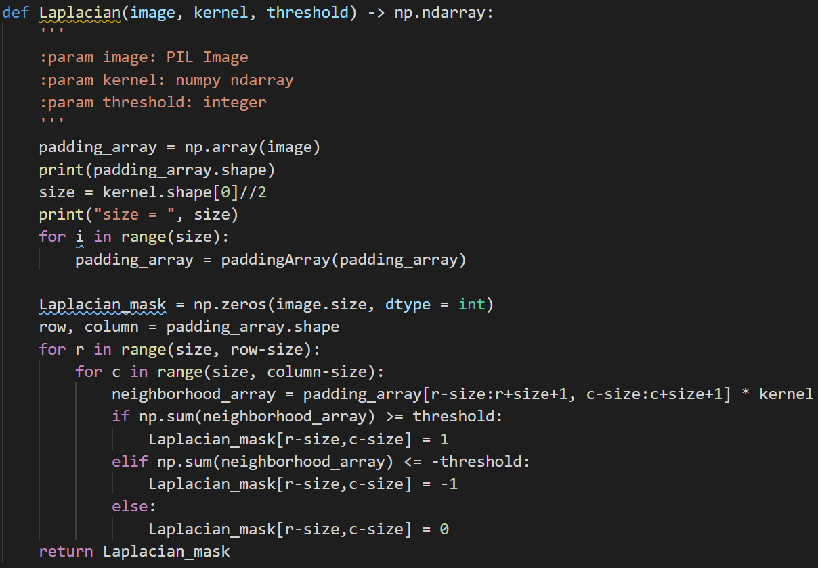
3. def zero_crossing(array, threshold, kernel): zero-crossing edge detection

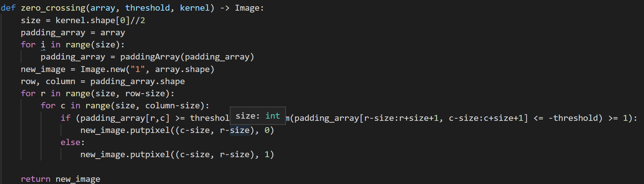

**Result:**

(a) Laplace Mask1 (0, 1, 0, 1, -4, 1, 0, 1, 0): 15

|  |  |  |
| --- | --- | --- |
|  |  |  |
| 原圖 | Threshold = 15 | Threshold = 20 |

(b) Laplace Mask2 (1, 1, 1, 1, -8, 1, 1, 1, 1)

|  |  |  |
| --- | --- | --- |
|  |  |  |
| 原圖 | Threshold =15 | Threshold = 20 |

(c) Minimum variance Laplacian: 20

|  |  |  |
| --- | --- | --- |
|  |  |  |
| 原圖 | Threshold =20 | Threshold = 15 |

(d) Laplace of Gaussian: 3000

|  |  |  |
| --- | --- | --- |
|  |  |  |
| 原圖 | Threshold =3000 | Threshold = 5000 |

(e) Difference of Gaussian: 1

|  |  |  |
| --- | --- | --- |
|  |  |  |
| 原圖 | Threshold =1 | Threshold = 4 |